**Master Functional Document**

|  |  |
| --- | --- |
| **Application** | NGERP – Centra |
| **Service Bundle** | Master Management |
| **Service Request** | Country Provinces and City |

**Description:**

In Compiere **(NGERP – Centra)**  application, the "Countries, Provinces, and Cities" window defines the address components in the system. It links provinces to countries and cities to either provinces or countries. Countries are usually set up at the system level and are used in business partner location records.

**Workflow Process:**

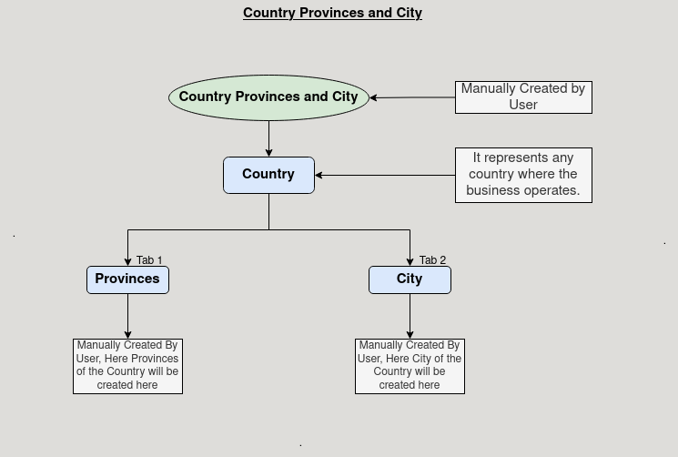

**Business Rules:**

* **Country Provinces and City** is visble in both **HQ** and **ROW**
* Creation is possible in both HQ and ROW.
* Provinces must be linked to a specific country. A province cannot exist without being associated with a country.
* Cities must be linked to either a province or directly to a country. If provinces exist, cities should be associated with a province; otherwise, they are linked directly to the country.